ADDITIONAL GUARD FEES
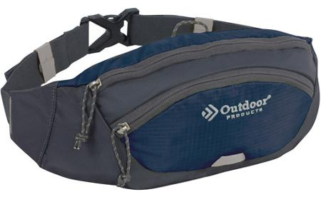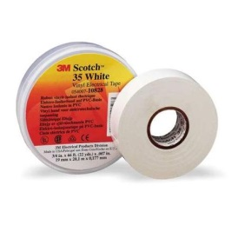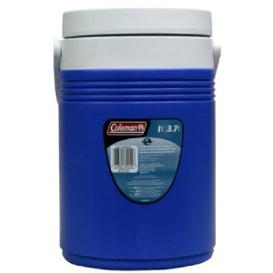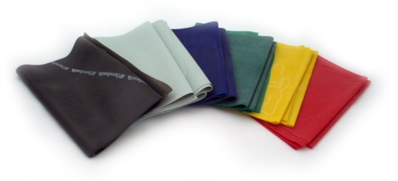

ITEMS APPROXIMATE PRICING
Dot Book Spiral bound index cards 100 count $2-5
Fanny Pack $5-10
Water Jug Gallon $5-10
Thera band $5-10
White Electrical Tape $3-5
Optional : Guard Section Shirt $15-20
Makeup this will be decided later in the summer and is usually around $15-20

Warm-ups: the warm-ups that we currently have are around $55 for the jacket and $30 for the pant. However, the guard staff is looking to redesign the warm-ups to something more unique to the Powhatan Guard using screen printing technology. More information will be given out at the parent meeting before any decisions are made.

